Faculty of Computing


Vulnerability
Assessment

Project Report

Submitted to:
Mr. Yawar Abbas
Submitted by:
Muhammad Shahab Qamar
Asim Khurshid
SAP: 54604,53653
BS CYB 6-1

Project Overview
IoTGuard is a comprehensive security assessment platform designed for WiFi networks and IoT devices. Built as a cybersecurity semester project, it combines multiple discovery techniques, port scanning, credential testing, CVE analysis, CVSS scoring, OWASP IoT mapping, and professional reporting into a single, user-friendly GUI application.
Purpose: To provide network administrators, security researchers, and homeowners with a powerful tool to audit their networks for vulnerable IoT devices and misconfigurations.
Key Strengths:
- All-in-one security assessment platform
- No cloud dependency (all data stays local)
- Professional reporting ready for client delivery

Technology Stack
Backend
Technology | Purpose
Python 3.10+ | Core language
asyncio | Concurrent operations
threading | Background scan workers

GUI Framework
Technology | Purpose
PyQt6 6.5+ | Main application window
matplotlib | Charts and graphs
QSS | Custom styling

Network Scanning
Technology | Purpose
Scapy | Packet manipulation, ARP scanning
nmap | Port scanning, service detection
nmcli | WiFi network discovery
zeroconf | mDNS/Bonjour discovery
bleak | BLE device scanning
aiohttp | Async HTTP requests

Data & Reporting
Technology | Purpose
SQLite | Scan history, caching, metadata
ReportLab | PDF report generation
json | Structured data export

APIs Integrated
API | Purpose
NVD 2.0 | CVE lookup
Shodan | External exposure check
ip-api.com | Geolocation & ISP detection

System Architecture
IoTGuard follows a clean, modular layered architecture:

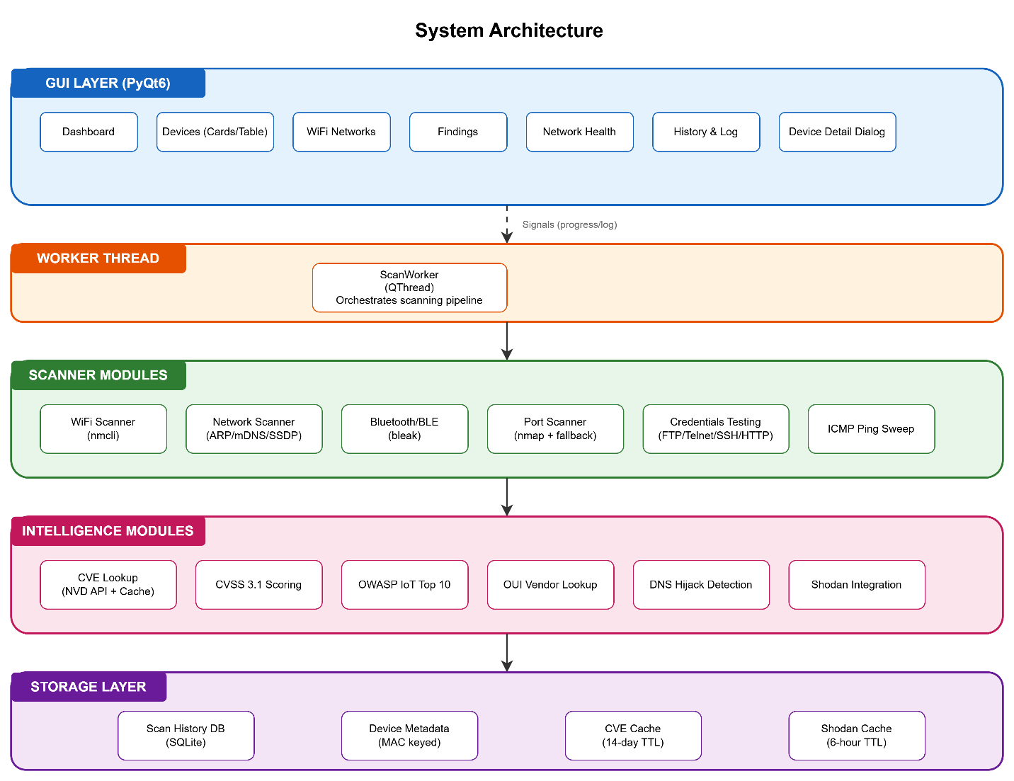
Data Flow:
- User initiates scan from GUI
- ScanWorker spawns in separate thread
- Scanner modules discover devices, ports, and services
- Intelligence modules enrich findings with CVE, CVSS, OWASP data
- Results stored in SQLite databases
- GUI updates in real-time with progress signals
- User exports reports (HTML/PDF/JSON)
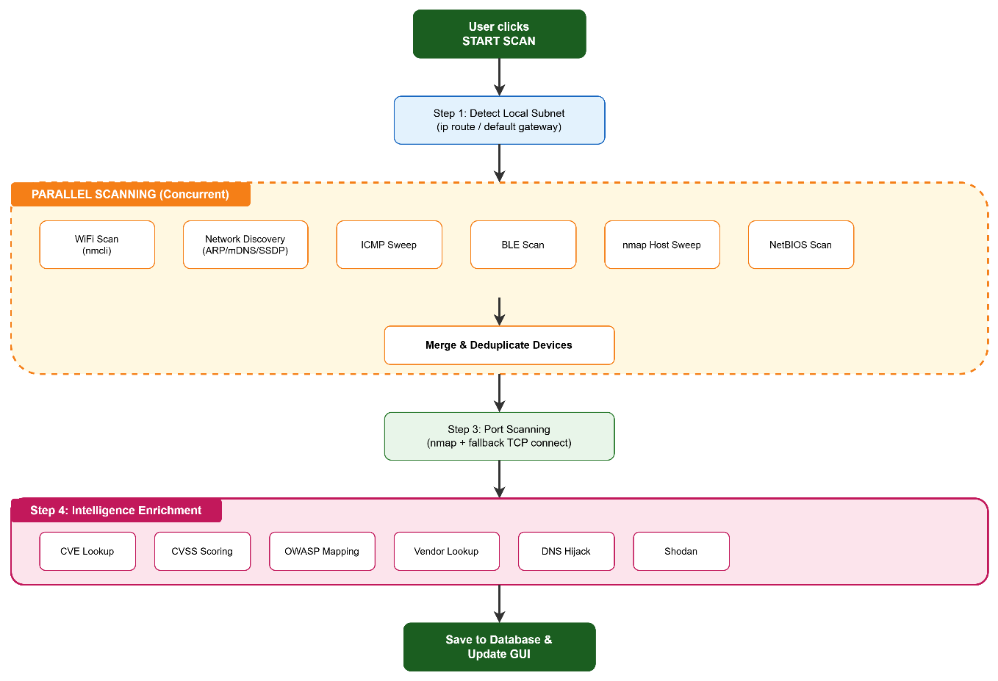

Complete Features List

Core Scanning Features
Feature | Description
WiFi Network Discovery | Passive scan via nmcli with encryption detection
Multi-Technique Discovery | ARP, mDNS, SSDP, nmap, ICMP, NetBIOS For devices
Bluetooth/BLE Scanning | Passive proximity discovery for wearables/IoT
Port Scanning | Full integration with version detection
Fallback Port Scanner | Pure-Python TCP connect when nmap unavailable
Service Detection | Identifies HTTP, SSH, Telnet, FTP, SNMP, UPnP, SMB

Intelligence & Enrichment
Feature | Description
CVE Lookup | NVD 2.0 API with 14-day SQLite cache
CVSS 3.1 Scoring | Full base metric calculation per NIST spec
OWASP IoT Top 10 | Maps findings to 10 standard categories
OUI Vendor Lookup | Device manufacturer from MAC address
DNS Hijack Detection | Compares router DNS vs Cloudflare reference
Shodan Integration | External port exposure check (optional API key)
Geolocation | ISP and location from public IP

User Experience Features
Feature | Description
Fing-Style Device Cards | Iconic grid with risk-tinted borders
Cards/Table Toggle | Switch layouts with one click
Custom Device Names | Persistent per-MAC metadata
Device Notes | Free-text notes saved locally
First-Seen Tracking | Automatic timestamp on first discovery
Last-Seen Tracking | Updated each time device appears
Intruder Alert Banner | Red alert for new MACs between scans
Per-Device Actions | Ping, traceroute, Wake-on-LAN, copy IP/MAC
Search & Filter | Live filtering by name, IP, MAC, vendor, risk
Right-Click Menus | Quick access to device actions

Network Health Tab
Feature | Description
Public IP Detection | Via ip-api.com (free, no key required)
ISP Detection | Shows internet service provider
Local Network Info | Gateway, local IP, DNS servers
Interface Detection | Automatically finds active interface
Internet Latency | Probes Cloudflare (1.1.1.1) and Google (8.8.8.8)
Shodan Exposure | Externally-visible ports on router
DNS Hijack Check | Tests 5 high-signal domains

Reporting & Export
Format | Features
HTML | Single-file with inline CSS, works offline, email-safe
PDF | Professional layout via ReportLab, A4 portrait
JSON | Full structured data for integration

Discovery & Scanning Capabilities
Technique | Type | Coverage
nmap host sweep | Active | Excellent
ARP sweep | Active | Same subnet
ICMP ping sweep | Active | Network
mDNS/Bonjour | Passive | Responsive devices
SSDP/UPnP | Active | IoT/routers
NetBIOS/NBT-NS | Active | Windows/NAS
Passive sniff | Passive | All traffic

Port Scanning Capabilities
- Primary Scanner: nmap with -sV --version-intensity 3
- Fallback Scanner: Pure-Python TCP connect scanner
- Ports Scanned: 50+ common IoT ports
- Concurrency: 8 parallel workers (configurable)
- Services Detected: HTTP, HTTPS, SSH, Telnet, FTP, SNMP, UPnP, SMB, RTSP, and custom services
Output: CVEs, descriptions, CVSS scores, references

OWASP IoT Top 10 Mapping (2018)
Category | Description | Example Findings
I1 | Weak/Guessable Passwords | Default credentials found
I2 | Insecure Network Services | Telnet open, FTP open
I3 | Insecure Ecosystem Interfaces | Rogue AP detected
I4 | Lack of Secure Update | Outdated firmware
I5 | Outdated Components | Known CVEs present
I6 | Privacy Protection | Cleartext credentials
I7 | Insecure Data Transfer | HTTP instead of HTTPS
I8 | Lack of Device Management | No logging, no alerts
I9 | Insecure Default Settings | WPS enabled, hidden SSID
I10 | Physical Hardening | (Informational only)

Tab Details
Tab | Content | Features
Dashboard | Charts & metrics | Risk distribution, device types, top CVSS scores
Devices | Device cards or table | Sortable, filterable, right-click actions
WiFi | Networks table | SSID, encryption, signal, channel, findings
Findings | Vulnerabilities table | Risk, CVSS, OWASP category, remediation
Health | Network status | Public IP, ISP, latency, DNS check, Shodan
History | Past scans | Timeline view, diff comparison
Log | Real-time output | Scan progress, debug info, copy to clipboard

Device Cards
Each device displays as a card with:
- Icon: Device type (router, camera, phone, TV, printer, NAS, wearable)
- Border Color: Risk level (green=Low, orange=Medium, red=High, dark=Critical)
- Status Dot: Green=Online, Gray=Offline
- Gateway Badge: ⚡ marker on router/gateway
- Device Name: Customizable by user
- IP Address: Click to copy
- MAC Address: Truncated, click to copy
Right-Click Menu:
- Rename device
- Edit notes
- Copy IP address
- Copy MAC address
- View details
- Delete from metadata
Double-Click: Opens Device Detail Dialog

Device Detail Dialog
Four tabs with comprehensive device information:
Tab | Content
Overview | Name, IP, MAC, vendor, type, first/last seen, notes
Open Ports | Port numbers, services, versions
Findings | All vulnerabilities for this device
Services | Detailed service information

Actions Available:
- Ping device
- Traceroute
- Wake-on-LAN (if MAC known)
- Quick port check
- Open web UI (if HTTP/HTTPS detected)

Intruder Alert Banner
- Trigger: New MAC address appears between scans
- Appearance: Red banner at top of device list
- Content: INTRUDER ALERT: New devices detected: 192.168.1.105 (Unknown Device)"
- Action: Click to see all new devices
- Auto-hide: Dismissable, reappears on next intrusion

Conclusion
IoTGuard is a complete, security assessment platform that successfully delivers:
- Comprehensive Discovery - 8 different techniques to find devices on networks
- Intelligent Analysis - CVE lookup, CVSS scoring, OWASP mapping
- Professional Reporting - HTML, PDF, and JSON exports
- Polished User Experience - Intuitive GUI with device cards, filters, and actions
- Safe Operation - Demo mode, optional lab mode, local data storage
- Modular Architecture - Clean separation of concerns, easy to extend
The project demonstrates strong software engineering practices including:
- Clean layered architecture
- Asynchronous operations
- Thread-safe GUI updates
- Graceful fallbacks for missing dependencies
- Persistent storage with caching
IoTGuard is ready for:
- Cybersecurity student projects
- Network administrator audits
- Home network security assessments
- IoT security research
- Classroom demonstrations

